DEVELOPMENT OF E-PORTAL FOR CASE MANAGEMENT HEARING AND FACILITATION OF LEGAL PROCEEDINGS

SUBMITTED IN PARTIAL FULFILLMENT FOR THE REQUIREMENT OF THE AWARD OF DEGREE OF

BACHELOR OF TECHNOLOGY
IN
COMPUTER SCIENCE



Submitted by
AADITIYA TYAGI (2200290120001)
AKSHAT JAIN (2200290120019)
ANKIT CHAUDHARY (2200290120032)
AKASH TIWARI (2200290120016)
.
Supervised by
Mr. Anmol Jain
Assistant Professor
Session 2023-24

DEPARTMENT OF COMPUTER SCIENCE
Krishna Institute of Engineering & Technology (KIET)
Ghaziabad, Delhi-NCR, Uttar Pradesh, India
Feb 2026
DECLARATION
We hereby declare that this submission is our own work and that, to the best of our knowledge and belief, it contains no material previously published or written by another person nor material which to a substantial extent has been accepted for the award of any other degree or diploma of the university or other institute of higher learning, except where due acknowledgment has been made in the text.

Signature
Name:- Aaditiya Tyagi, Akshat Jain, Akash Tiwari, Ankit Chaudhary
Roll No.:- 2200290120001, 2200290120019, 2200290120016, 2200290120032
Date:-15/02/2026

CERTIFICATE

This is to certify that Project Report entitled “Development of E-Portal for Case Management Hearing and Facilitation of Legal Proceedings” which is submitted by Aaditiya Tyagi, Akshat Jain, Akash Tiwari and Ankit Chaudhary in partial fulfillment of the requirement for the award of degree B. Tech. in Department of Computer Science of Dr. A.P.J. Abdul Kalam Technical University, Lucknow is a record of the candidates own work carried out by them under my supervision. The matter embodied in this report is original and has not been submitted for the award of any other degree.
.

Date: 15/02/2026 | Supervisor
 | Mr. Anmol Jain
 | (Assistant Professor)
Date: 15/02/2026 | Dr.Ajay Kr Srivastava
 | (Dean CS)

ACKNOWLEDGEMENT

We are delighted to submit the report for B. Tech Project that we have carried out during B. Tech. Final Year. We would like to express our heartfelt gratitude to Professor Mr. Anmol Jain, Department of Computer Science, KIET, Ghaziabad, for his unwavering support and valuable guidance during the entire period of our project work. His dedication and focused effort have always been our source of inspiration and motivation. Without his thoughtful and kind consideration and help, our efforts would not have been this successful.
It gives us great pleasure to express our deep gratitude to Dr Ajay Kr Srivastava, Dean of the Department of Computer Science, KIET, Ghaziabad, for his commitment and help in the project. Also, we would like to express our gratitude to the faculty members of the department who have always been very supportive and cooperative during our project period.
Finally, but by no means the least, we would like to extend our sincere thanks to our friends who contributed to the successful completion of the project.

Date : 15/02/2026
Signature : | Signature : | Signature : | Signature :
Name : Aaditiya Tyagi | Name : Akshat Jain | Name : Akash Tiwari | Name : Ankit Chaudhary
Roll No.: 2200290120001 | Roll No.: 2200290120019 | Roll No.: 2200290120016 | Roll No.: 2200290120032

ABSTRACT

Aiming to streamline the civil and criminal case management processes and conduct of virtual courts, the researchers endeavored to develop a common, technology-based system that would cater to the varying requirements of the legal fraternity. Main idea was to deliver a comprehensive system connecting all the users of the system, including judges, advocates, litigants, court staff and system administrators and thereby cut on the manual and paper based process. The portal supports the complete digital case management by allowing online case registration, secure uploading of documents, automatic scheduling of hearings, and smooth conduct of virtual courts through the embedded video conferencing facility. For operational effectiveness and responsibility the system includes instantaneous notifications alerts and nudges for all those concerned Built on the MERN stack the portal is security scalable and high-performing Role-based access control guarantees that users operate within their granted privileges and the system remains comprehensive flexible and comprehensible to the continuously changing requirements of the judiciary.

TABLE OF CONTENTS | Page No.
DECLARATION……………………………………………………………………. | ii
CERTIFICATE……………………………………………………………………… | iii
ACKNOWLEDGEMENTS…………………………………………………………. | iv
ABSTRACT……………………………………………………………………….... | v
LIST OF FIGURES…………………………………………………………………. | viii
LIST OF TABLES…………………………………………………………………… | ix
LIST OF ABBREVIATIONS………………………………………………………. | x
SDG Mapping………………………………………………………. | xi
CHAPTER 1 INTRODUCTION
1.1 Introduction to Project
1.2 Project Category
1.3 Objectives
1.4 Structure of Report

CHAPTER 2 LITERATURE REVIEW
2.1 Literature Review
2.2 Research Gaps
2.3 Problem Formulation

CHAPTER 3 PROPOSED SYSTEM
3.1 Proposed System
3.2 Unique Features of The System

CHAPTER 4 REQUIREMENT ANALYSIS AND SYSTEM SPECIFICATION
4.1 Feasibility Study (Technical, Economical, Operational)
4.2 Software Requirement Specification
4.2.1 Data Requirement
4.2.2 Functional Requirement
4.2.3 Performance Requirement
4.2.4 Maintainability Requirement
4.2.5 Security Requirement
4.3 SDLC Model Used
4.4 System Design
4.4.1 Data Flow Diagrams
4.4.2 Use Case Diagrams
4.5 Database Design

CHAPTER 5 IMPLEMENTATION
5.1 Introduction Tools and Technologies Used.

CHAPTER 6 TESTING, AND MAINTENANCE
6.1 Testing Overview
6.2 Types of Testing Performed
6.2.1 Functional Testing
6.2.2 Integration Testing
6.2.3 Security Testing
6.2.4 Performance Testing
6.3 Test Case Design
6.4 Test Environment
6.5 Test Results and Observations
6.6 Maintenance Strategy
6.7 Conclusion of Testing and Maintenance

CHAPTER 7 RESULTS AND DISCUSSIONS
7.1 Description of Modules with Snapshots
7.2 Key findings of the project
7.3 Brief Description of Database with Snapshots

CHAPTER 8 CONCLUSION AND FUTURE SCOPE
8.1 Conclusion
8.2 Future Scope
LIST OF FIGURES
Figure No. | Description | Page No.
4.1 | Agile Development Methodology | 17
4.2 | System Architecture | 18
4.3 | DFD Level 0 | 19
4.4 | DFD Level 1 | 20
4.5 | Use case Diagram | 21
4.6 | ER Diagram | 23
7.1 | E-portal Dashboard | 30
7.2 | Admin Login page | 31
7.3 | Admin Panel | 31
7.4 | Litigant Dashboard | 32
7.5 | Database Case Document | 33

LIST OF TABLES

Table. No. | Description | Page No.
3.1 | Overview of the Proposed System | 8
3.2 | Unique Features and Their Benefits | 9
3.3 | Comparison with Traditional System | 9
4.1 | Technical Feasibility Analysis | 10-11
4.2 | Economic Feasibility Analysis | 11
4.3 | Operational Feasibility Analysis | 12
4.4 | Database Entities Description | 22-23
5.1 | Tools and Technologies Used | 24-25
6.1 | Sample Test Cases | 27
6.2 | Test Environment Configuration | 27-28
6.3 | Maintenance Activities | 29
7.1 | Key Findings Summary | 32
LIST OF ABBREVIATIONS

AI | Artificial Intelligence
AIS | Automated Information System
API | Application Programming Interface
COVID-19 | Coronavirus Disease 2019
CSS | Cascading Style Sheets
DFD | Data Flow Diagram
EAEBJOL | Ex Aequo Et Bono Journal of Law
ICT | Information and Communication Technology
JWT | JSON Web Token
KRI | Kurdistan Region of Iraq
MFA | Multi-Factor Authentication
MERN | MongoDB, Express.js, React.js, Node.js
REST | Representational State Transfer
SDG | Sustainable Development Goal
SDLC | Software Development Life Cycle
SSL | Secure Sockets Layer
TLS | Transport Layer Security
UNDP | United Nations Development Programme

SDG MAPPING
SDG No. | Sustainable Development Goal | Relevance to the Project
SDG 9 | Industry, Innovation and Infrastructure | The project develops a scalable, secure digital infrastructure for courts using modern web technologies, promoting innovation in judicial services.
SDG 10 | Reduced Inequalities | By providing online access to case filing, hearings, and documents, the system ensures equal access to justice irrespective of location or socio-economic background.
SDG 11 | Sustainable Cities and Communities | Digitization of court processes reduces physical visits, paperwork, and delays, contributing to efficient and sustainable urban governance.
SDG 16 | Peace, Justice and Strong Institutions | The e-Portal enhances transparency, accountability, and efficiency in judicial processes, strengthening institutional trust and access to justice.

This initiative supports the United Nations Sustainable Development Goals through the application of digital tools to overhaul judicial operations and directly supports SDG 9 by creating an advanced and scalable digital platform for case management and hearings. Facilitating remote mode of judicial service delivery it promotes SDG 10 by ensuring inclusivity for underserved and geographically isolated populations, and by cutting service access costs. The alleviation of bureaucratic procedures, reduction in in-person court hearings and administrative lags encourages SDG 11 to establish sustainable and functional communities.

CHAPTER 1
INTRODUCTION

  - Introduction to Project
Advancements in digital technologies have greatly affected the transformation of a majority of public service sectors. Still, judicial systems in many parts of the world continue to depend mostly on manual and semi, digital processes. Such traditional methods usually cause delays and lack of transparency while also increasing the workload of the courts, legal professionals, and litigants. Besides, when we think of case filing, scheduling hearings, document handling, and the tracking of the progress of the case, through the old, fashioned ways, these are just some of the areas that hugely contribute to the cases backlogs and inefficiencies in the procedures.
The E, Portal for Facilitating Case Management and Hearings is a digital solution that is comprehensive and addresses the challenges brought about by the above, mentioned issue. Its objective is to create a single, web, based platform that would serve as a communication tool between judges, advocates, litigants, court staff, and administrators. The portal, by integrating and automating core judicial workflow like case filing, hearing scheduling, document management, and notifications, aims at increasing efficiency, ensuring that the judicial process is accessible and transparent all at the same time.
The proposed e, portal, which is going to be developed using up, to, date web technologies, will enable secure, role, based access that can be scaled to the size of a real, world court environment. This is a very important project since it is a step towards the digital transformation of the judiciary which will ultimately result in the timely delivery of justice and a better user experience of all stakeholders involved.
  - Project Category
The idea suggested by the project is an "E, Portal to Facilitate Case Management and Hearings" which in essence is a Web, Based Application / E, Governance System. It is a software engineering and full, stack development project focusing on the digital transformation of judicial processes through the utilization of the latest web technologies.
This project is an E, Governance Application since it supports the digital delivery of public judicial services; a Web, Based Information System because it is capable of handling case data, users, documents, and workflows; and a Role, Based Management System since it provides access to judges, advocates, litigants, court staff, and administrators.
The framework works on client, server architecture and follows the standard software development lifecycle phases such as requirement analysis, system design, implementation, and testing. Furthermore, it is built with features like automation, transparency, security, and scalability in mind, thereby making it suitable for real judicial environments.

  - Objectives
The main objectives of the E-Portal for Facilitating Case Management and Hearings project are as follows:
- To design and develop a centralized web-based platform for managing judicial cases and hearings efficiently.
- To automate the process of case filing, scheduling of hearings, and tracking of case status.
- To provide secure, role-based access for judges, advocates, litigants, court staff, and administrators.
- To enable digital document submission, storage, and retrieval in a structured and secure manner.
- To reduce manual paperwork, administrative delays, and dependency on physical court visits.
- To enhance transparency and accessibility in judicial proceedings through real-time notifications and updates.
- To ensure data security, confidentiality, and integrity of legal records using appropriate authentication and authorization mechanisms.

  - Structure of the Report
This project report is organized into multiple chapters, each focusing on a specific aspect of the system development and analysis:
Chapter 1 – Introduction
Presents an overview of the project, its category, objectives, and the overall structure of the report.
Chapter 2 –Literature Review
Reviews existing systems and related research work, identifies research gaps, and formulates the problem addressed by the project.
Chapter 3 – Proposed System
Describes the proposed e-Portal in detail along with its architecture and unique features.
Chapter 4 – Requirement Analysis and System Specification
Discusses feasibility analysis, software requirements, system design models, and database design.
Chapter 5 – Implementation
Explains the tools, technologies, and methodologies used to implement the system.
Chapter 6 – Testing and Maintenance
Covers testing techniques, test cases, and system maintenance aspects.
Chapter 7 – Results and Discussions
Presents system modules, results, snapshots, key findings, and database descriptions.
Chapter 8 – Conclusion and Future Scope
Summarizes the project outcomes and discusses possible future enhancements.
References
Lists all cited works in IEEE format.

CHAPTER 2
LITERATURE REVIEW

  - Literature Review
Legal informatics have gone through a sea change with the advent of e-justice systems and virtual courts. During the pandemic, the importance of technology became yet greater. Courts all over the world had to transition to remote and online modes. Though there have been various efforts to computerize court processes, most such systems are not strong enough to support multiple user roles on a single secure and scalable platform. This project henceforth tries to present a comprehensive role-based system with secure video conferencing capabilities that have not been fully utilized in previously published works [1]-[3].
Prasetyo et al. [5] assessed the effectiveness of applying electronic court services in Indonesia’s Religious Courts after Supreme Court Regulation No.7 of 2022. It brought electronic filing, online payments, e-summons and video hearings into the equation, when the Libyan legal system underwent a modernisation. Coming fast out of this transformation, the study which looked at the system’s progress used a very formalised legal approach, sprinkled in with real-world observations, and found that it was not only more efficient, but more transparent as well.
Well-known problems like patchy technology, users who don't know what they’re doing, and the requirement for regular check-ins, highlighted that the system needs a lot of training and standardisation to be perfected. Jaber [7] proposed a multi-factor authentication system, or MFA, to secure Libya's e-government portal Dawlaty, which uses the link between SIM cards and National ID and sends a one-time password to the user. Coming from the success of its use in the Central Bank of Libya’s Foreign Currency Management System, this approach improved the validation of users, reduced fraud, and basically won over the hearts of the people who use the service, it’s cost-effective and very easy to set up.
However, the possibility of SIM-swap fraud, intercepted messages, and inadequate network coverage in rural areas showed that the system could be improved.
Nababan et al. [6] researched the implementation of online trials in civil cases at the Medan District Court in Indonesia.
Nababan et al. [6] have discussed the adoption of online trials in civil cases in the Medan District Court in Indonesia. E-submission of documents, e-hearings, and pronouncement of judgment were facilitated through the e-court rules provided by the Supreme Court. This, in turn, helped promote easier access to trials, making them both speedier and cheaper. Data for 2021-2024 showed increased public engagement with e-courts. However, challenges remained regarding unstable internet signals, delays in manual wire transfers, and other issues with regard to witness security and honesty.
Grepon [13] spearheaded the pioneering project in court automation for Northern Mindanao, Philippines, using the Web-based Case Docket Information System. The project upgraded the management of dockets, made the court reports computerized, and provided enough security to the data through cloud infrastructure. The system was designed using PHP, HTML, CSS, and JavaScript, following the SDLC model. It increased efficiency significantly. However, there are also indications that further work is needed to address scalability and internet connectivity issues, as well as its deployment to only one branch.
In another regional case, Maralbaeva [10] considered the interlinkage between cybersecurity and e-justice in Kyrgyzstan. The novelties of e-justice and 'Sud' AIS provided a boost for transparency and access but entailed certain risks regarding data security—particularly sensitive information of a personal nature. Research on 280 cases of domestic violence disclosed a lack of thorough anonymization and much-needed legal protection by means of cybersecurity. Access remains highly insufficient for persons with disabilities, therefore necessitating inclusive design for digital justice systems.
Ahmed et al. [11] investigated the adoption of an e-court system in the KRI because of its enhancement of judicial transparency. They took a sequential mixed-methods approach, utilising a survey, interviews, and observations, when the researchers investigated the use of digitization in the court system. Digitization enabled them to track, distribute and access the data fairly. However, the dearth of data and delayed responses severely hindered the reliability of the findings, and the authors stressed that the transparency of the data is an essential requirement, with coming across trustworthy court performance metrics being a real challenge.
In his proposed constitutional framework for the e-justice system in Taiwan, Lee [12], presented a delicate balance between judicial efficiency and privacy and transparency.
Similar to the e-litigation and e-administration systems, especially the COVID-19 era, which introduced efficiency and reduction of paperwork, the study warned against dependence on ICT that undermined judicial independence. Comparing these with other European blueprints such as e-CODEX and e-SENS pointed toward human intervention, regulatory demands, and constant training of the judicial workforce. Theoretically sound, the empirical evidence and public response limited the useful implementation of the findings.
The latest research by Prabhavati et al. [8] introduces Legal Connect, an end-to-end e-portal for case and hearing management. Legal Connect is more efficient concerning central processing of data, automation of scheduling, real-time communication, and analytics in re-engineering of legal processes compared to silo legacy systems. The system addresses most of the gaps in the previous text with a priority on security, standardization, and accessibility.
Although existing solutions like Legal Connect and other regional e-justice systems offer complete functionalities for digital case management, prior studies are mostly descriptive. Little attention is paid to empirical validation in the form of performance metrics, delay reduction analysis, and user satisfaction assessment. The aim of this paper is to discuss an evaluation-driven analysis of a role-based e-court portal.
  - Research Gap
While reviewing extant literature and current e, court and judicial management systems, research gaps have come up. Most of the existing studies that have been conducted tend to be concentrated on the introduction of digital court systems scarcely giving an empirical evaluation of the performance, efficiency, and user satisfaction of the studied systems. There is a paucity of a comprehensive study that gives a breakdown of aspects such as the extent of delay of cases, the system's response time when there is concurrent usage, and the practical usability of the judicial stakeholders in different situations.
Moreover, numerous existing systems include partial digitization, for instance, online filing or case tracking, yet they still don't offer an end, to, end, role, based platform that integrates case management, hearing scheduling, document handling, and notifications within a single secure system. Problems regarding scalability, access control, data security, and inclusiveness are in most cases not adequately dealt with.
Besides, there has been only a small number of studies that have looked into the effects of such digital platforms on transparency, accessibility, and administrative efficiency in the judicial process. The above differences make it clear that there is a strong demand for a single, evaluation, driven e, Portal that not only digitizes judicial workflows but also assesses its effectiveness through measurable performance and usability metrics.
  - Problem Formulation
The traditional judicial case management system is mostly based on manual and semi, digital processes, thus it is very inefficient and the consequences are delayed case filings, scheduling conflicts, no real, time updates, and tons of unnecessary paperwork. These shortcomings lead to growing case backlogs, lowering of transparency, and inconveniences for judges, advocates, litigants, and court staff. Existing digital solutions are often only a part of the picture, they have limited functionality and they do not seamlessly integrate case filing, hearing management, document handling, and notifications.
The issue at hand in this project is that there is a lack of a single, secure, and role, based digital platform that can accurately manage the entire judicial workflow while also ensuring transparency, accessibility, and scalability. Additionally, there is a requirement for a mechanism that can be empirically assessed for its performance, usability, and efficiency under actual conditions.
Therefore, this project identifies the problem as the creation and establishment of a complete e, Portal that automates judicial case management and court hearings, thus decreasing manual work, delaying the process less, and making the judicial process more effective overall.

CHAPTER 3
PROPOSED SYSTEM

  - Proposed System
The proposed system is a web, based E, Portal for Facilitating Case Management and Hearings which aim to digitize and speed up judicial processes. It enables a centrally coordinated environment for case filing, hearing scheduling, document handling, and instant notifications with the guarantee of secure, role, based access of various stakeholders in the judicial ecosystem.
The portal accommodates various user roles of Judges, Advocates, Litigants, Court Staff, and Administrators, who are all given different access rights. It brings automation to the judicial workflows, therefore, lessens the reliance on manual paperwork, and also limits the delays that are typical of the traditional court procedures. The use of up, to, date web technologies and a modular and scalable architectural design has been implemented in the creation of the system, thereby making it fit for real, world deployment in judicial establishments.
The proposed system covers essential features such as online case registration, automated hearing scheduling, digital document management, notification services, and secure authentication. Through transparency and accessibility, the system is geared towards achieving higher productivity, lessening the backlog of cases, and increasing user satisfaction.
Table 3.1: Overview of the Proposed System
Component | Description
User Management | Role-based authentication and authorization for all stakeholders
Case Management | Online case filing, tracking, and status updates
Hearing Management | Automated scheduling and conflict resolution
Document Management | Secure upload, storage, and version control of legal documents
Notification System | Real-time alerts via email/SMS for hearings and updates
Security Layer | JWT-based authentication and access control

  - Unique Features of the System
The proposed e, Portal comes with several innovative features that set it apart from the current judicial management systems. In contrast to traditional platforms which only offer partial digitization, this system facilitates completely automated judicial workflows without even leaving one interface. Through role, based access, the system upholds confidentiality and data integrity and simultaneously allows the users to carry out their tasks efficiently.
Besides that, the system points out scalability and performance as key focus areas, thus enabling it to support multiple users accessing the system at the same time without experiencing slowdowns. Communication between stakeholders is improved through automated notifications and real, time updates, whereas centralized document management guarantees the legal records' traceability and auditability.
Table 3.2: Unique Features and Their Benefits
Feature | Benefit
Role-Based Access Control | Prevents unauthorized access and ensures data confidentiality
End-to-End Workflow Automation | Reduces manual effort and administrative delays
Centralized Document Repository | Improves document traceability and version control
Automated Notifications | Keeps stakeholders informed in real time
Scalable Web Architecture | Supports high user load and future expansion
User-Friendly Interface | Improves usability for technical and non-technical users

Table 3.3: Comparison with Traditional System
Parameter | Traditional System | Proposed System
Case Filing | Manual / Semi-digital | Fully Online
Hearing Scheduling | Manual | Automated
Document Handling | Physical Records | Digital & Secure
Transparency | Limited | High

CHAPTER 4
REQUIREMENT ANALYSIS AND SYSTEM SPECIFICATION

  - Feasibility Study
Looking at the practicality, sustainability and success of the E-Portal for Case Management in a very effective manner and Hearings, a feasibility study was conducted thoroughly, essentially it was acting as a test run to check the viability of the project. From a technological, financial and operational standpoint, the study made sure that the portal will be able to function very effectively in a real-world legal setting.
    - Technical Feasibility
When discussing the feasibility of the system, we have to take into account the availability of the necessary technology, infrastructure, and skills on site to build and deploy the system.
Well-known web-technologies like React at the front end, Node.js used for the back end and MongoDB for database management will allow us to achieve the very essential level of scalability, security and high availability. We've chosen RESTful APIs, JWT based authentication and secure HTTPS connections, all of which are very common, field-tested components in the industry.
Fortunately, the hardware and software requirements for the system are easily available in the market without any major restrictions. The development team we are planning to use, is technically competent and able to get the system up and running, plus provide its upkeep.
Table 4.1: Technical Feasibility Analysis
Parameter | Feasibility Status
Availability of Technology | Available
Development Tools & Frameworks | Open-source & Supported
Database Support | Available (MongoDB)
Security Mechanisms | Supported (JWT, SSL/TLS)
Scalability | High
Technical Expertise | Available

    - Economic Feasibility
Economic feasibility is a measure of whether the project is a good use of money and financially viable.
Basically, the proposed system is based on open, source technologies which lead to a great reduction in software licensing costs. Development, deployment, and maintenance costs are kept at a minimum by leveraging cloud, based infrastructure and reusing software components. Besides, the system is going to lower the running cost in the future by cutting down on paperwork, manual work, and people going to the court physically.
The advantages achieved in terms of increased efficiency, lessened administrative burden, and quicker case settlement are higher than the developmental cost of the project.

Table 4.2: Economic Feasibility Analysis
Cost Factor | Impact
Software Licensing | Minimal (Open-source)
Development Cost | Moderate
Maintenance Cost | Low
Infrastructure Cost | Scalable & Controlled
Long-term Operational Savings | High
Result: The project is economically feasible.
    - Operational Feasibility
Operational feasibility is used to evaluate that whether the system fits well and can be efficiently used in the existing judicial workflow.
The e, Portal features role, based dashboards, intuitive user interfaces, and automated workflows that make it easy for judges, advocates, litigants, and court staff to navigate. The user, friendly design and guided workflows mean that almost no training is needed. The system has been designed in such a way that its integration into existing judicial procedures is seamless and it does not interfere with legal processes.
Daily operations and user satisfaction are enhanced through the use of automated notifications, centralized document management, and real, time updates.
Table 4.3: Operational Feasibility Analysis
Aspect | Evaluation
User Acceptance | High
Ease of Use | High
Training Requirement | Minimal
Compatibility with Existing Process | High
Reliability | High
Result: The project is operationally feasible.
  - Software Requirement Specification
The Software Requirement Specification (SRS) outlines the main functional and non, functional features of the E, Portal for Facilitating Case Management and Hearings. It is a legal document that states what the system is supposed to do and the limitations it should follow. The SRS is used as a guideline for system design, development, testing, and validation during the entire project.
The system to be implemented is a web, based, role, managed, judicial platform, which will include functionalities for case filing, hearing scheduling, document management, notifications, and secure access control. Requirements were gathered through an analysis of the judicial procedures, stakeholder needs, and the drawbacks of current e, court systems. Security, system scalability, system usability, and reliability are given priority as the system deals with very confidential legal data and supports multiple user roles simultaneously.
The SRS also guarantees that the system:
- Accurately showcases the judicial workflow, needskeeps information confidential and safedelivers uninterrupted.
- services and good performancecan be easily upgraded in the futureThis document acts as a reference.
- point for system design and implementation and helps in meeting stakeholder expectations through the developed solution.
    - Data Requirements
The e, Portal for Facilitating Case Management and Hearings is a judicial tool that needs structured and secure handling of its data if it is to support efficiently the workflow of the courts. The system manages different types of data related to cases, users, hearings, and documents. All the data is kept in a single database both for the purposes of consistency and correctness, and also for ease of retrieval.
The major data entities are user data, case data, hearing data, document data, and notification data. User data is composed of personal and role, based information that enables the user to be authenticated and authorized. Case data is comprised of case number, case filing date of the case, present status of the case, and the judicial court number that is assigned to the case. Hearing data keeps information about the schedule of the hearing such as hearing dates, time slots, judge assignments, and outcomes of the hearing. Document data is legal documents submitted by authorized users together with such metadata as version, uploader role, and timestamps. Notification data keeps track of notifications that are sent to the stakeholders about case updates, hearings and filing information.
Proper secured access control mechanisms should be there to keep all the data safe and to prevent any unauthorized access. The system performs a data integrity checks through validation standards, unique identifiers, and audit trails based on blockchain. On top of that, the data model is designed to be scalable so as to be able to handle an gradually increasing number of cases and users without compromising any performance and reliability.
    - Functional Requirements
The functional requirements establish the main functions and activities that an E, Portal for Facilitating Case Management and Hearings has to support to satisfy the needs of its users and the system objectives. These requirements explain the reaction of the system to the actions of the users and the way it controls judicial workflows.
The system shall permit users to register and authenticate in a secure way by using role, based access control. Different roles such as judges, advocates, litigants, court staff, and administrators shall only have access to those features which they are authorized to use.
The system shall facilitate electronic case filing, by which litigants or advocates can submit case information and digitally upload the necessary documents.The system shall offer an automated hearing scheduling function that takes into account the availability of judges, their existing schedules, and the priority of the cases, and it shall inform all the concerned parties of the hearing schedules.
Moreover, it should allow document management so that the authorized users get the capability to upload, view, modify, and track legal documents with version control.The system shall offer a real, time case status feature so that any user can get updated information about the various stages of the judicial process.
Furthermore, it should be able to prepare and push out automated alerts for case filings, hearing schedules, and also the deadline reminders.Besides, the system shall also keep audit logs to record all the major activities for accountability and transparency purposes.
    - Performance Requirements
Performance requirements determine the level of efficiency with which the E, Portal for Facilitating Case Management and Hearings must function under normal as well as heavy usage. As the platform is expected to be used by different stakeholders simultaneously, it should guarantee. Performance of the system while being accessed simultaneously by multiple users should not degrade significantly. Most of the user request completions should be in the 2, 3 seconds time frame under normal load. The system needs to be able to accommodate a large number of case files and documents without losing data consistency and availability.It should be able to perform well during high usage times, such as the time of hearing schedules or when a lot of cases are being filed simultaneously .Good backend optimization and efficient database queries are necessary for the system to operate smoothly.
In sum, the system is to be dependable, consistent, and of high performance thus timely to facilitate the daily judicial operations efficiently.
    - Maintainability Requirements
The e-Portal for Case Management and Hearings is meant to be easily maintainable so that it can be used and can adapt for a long time. The system has a very modular architecture where separate parts like user management, case handling, scheduling, and notifications can be changed or updated independently and very easily without any disturbance in the whole system.
Follow standardized practices of coding, maintain a very clear documentation, and separate concerns in such a way that developers can easily locate them , can fix, and solve problems. The system is highly capable of supporting periodic updates as well as improvements so that new features can be integrated with very little interruption of the existing functions. Deployment to and maintenance of different environments are made easy by the use of configuration files and environment-based settings.
Moreover, the adoption of widely used open, source technologies guarantees that there will be long, term support and availability of developer resources. Performing regular backups, establishing logging mechanisms, and using version control are yet some ways to contribute to a stable and reliable system in the long run.
    - Security Requirements
The e, Portal for Facilitating Case Management and Hearings is an application that stores judicial and personal data of highly sensitive nature. Hence, it is absolutely imperative for the system's security to be very strong. It has to comply with the standard security requirements of confidentiality, integrity, and availability of all data, whether stored or in transmission.
The system is to make use of secure user authentication mechanisms combined with role, based access control, thereby restricting the users to only those who are authorized. The judge, advocate, litigant, court staff, and the administrator, each user role, shall have well, identified permissions that will prevent unauthorized actions. User sessions shall be secured and protected from misuse by using secure session management techniques.
Every communication between the client and the server shall be made over a secure network with encryption to make sure that no one could eavesdrop on the data. Critical elements like user credentials and case records should also be saved only in encrypted format. Furthermore, the system is to hold audit records of the users' activities that will serve for both accountability and notification of any unauthorized or suspicious incidents.
To make the system resistant to common vulnerabilities such as unauthorized access, data breaches, and injection attacks, security tests and validation shall be executed regularly. Such provisions give the assurance that the judicial data is safe and reliable all through the system's lifecycle.
  - SDLC Model Used
The development of the E- Portal for Facilitating Case Management and Hearings was based on the Agile Software Development Life Cycle. The Agile model was selected because of it’s flexibility, iterative nature, and ability to handle achanges in requirements that frequently occur in a very complicated systems like judicial platforms.
Under this methodology, the system is built in a series of small and easily manageable iterations. Each iteration includes requirement analysis, design, implementation, testing, and review. As a result, there is a constant and a very frequent flow of feedback from it’s stakeholders, and issues can be detected early and solved at a very early stage. Features like filing of the cases, hearing scheduling, document management, and notifications are developed and tested in many steps.
The Agile model enables development and testing to be done in parallel, thus saving time while ensuring quality. It also makes it possible for upgrades and fine, tuning to be done without disturbing the entire system. Therefore, such a model is ideal for a scalable, secure, and user, centric application like the planned e, Portal.

Figure 4.1. Agile Development Methodology
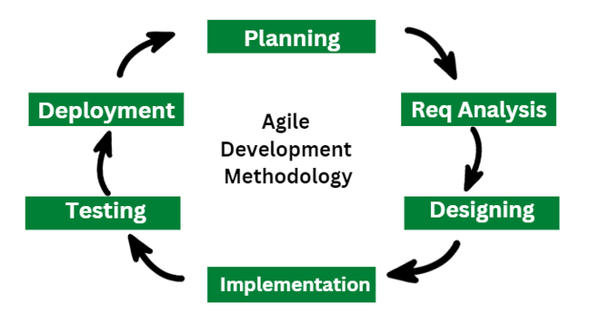
  - System Design
System design determines the whole structure, architecture and arrangement of an E-Portal. It takes the requirements which are figured out at the analysis stage and turns them into a design that serves as a map for the actual build and development. The design emphasizes aspects like scalability, security, modularity, and maintenance convenience along with supporting various user roles and simultaneous access.
The system is based on a layered architecture comprising presentation layer, application layer and data layer. The presentation layer is charged with the user interface through web applications. The application layer stores the business logic of functionalities like case management, scheduling, authentication, and notifications. The data layer isolates the storage and fetching of case records, profiles of the users , documents, and logs.
Role, based access control is built into the design so that different users are limited to only the parts of system functionalities they are allowed to use. Secure communication channels and authentication mechanisms are also part of the system architecture by design. Overall such a well-structured system facilitates efficient handling of workflows, it ensures data security, and enables different system components to interact very smoothly.
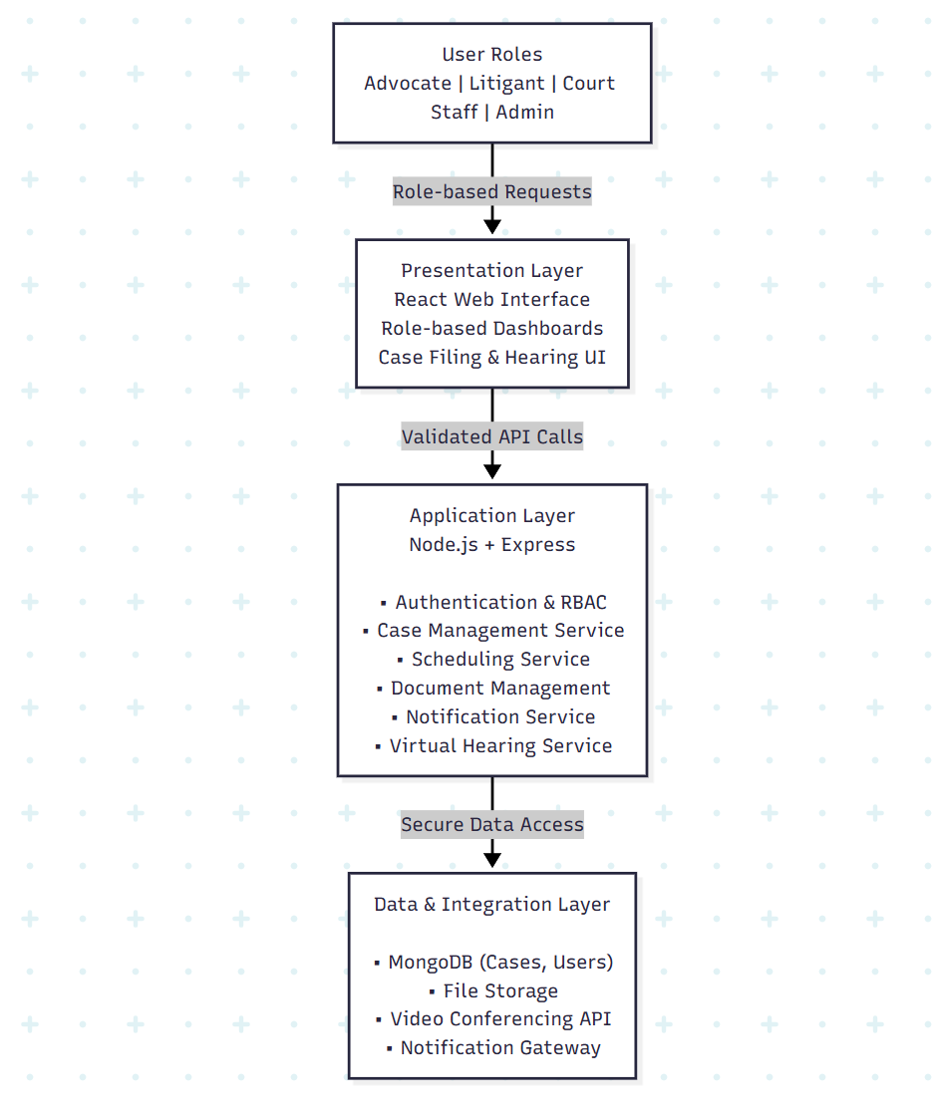
Figure 4.2. System Architecture
    - Data Flow Diagrams
Data Flow Diagrams (DFDs) are graphical illustrations that are used to depict the flow of data within the E, Portal for Facilitating Case Management and Hearings. Such diagrams clarify how data is exchanged among users, system processes, and data storage. In contrast to physical implementation, DFDs emphasize logical data movement thus they are often used for system analysis and design.
Two tiers of DFDs are adopted for the project namely: DFD Level 0 (Context Diagram) and DFD Level 1. The context diagram exhibits the whole system as one process from the viewpoint of the highest level, whereas Level 1 breaks down this process into various detailed sub, processes.
DFD Level 0 (Context Diagram)
The DFD Level 0 showcases the e-Portal as a single process and depicts its communication with the outside world entities. The major external entities considered are Judges, Advocates, Litigants, Court Staff, and all the Administrators. These entities provide inputs like case-details, documents, and scheduling requests to the system, and get outputs such as case status recent updates, hearing schedules, and notifications of various kind.
The main process, the E-Portal System, handles all requests coming in to the system, saves the necessary data in the database and the time, and prepares the correct responses. This figure emphasizes the system boundary and presents a very clear view of the data exchanges between the system and its users.
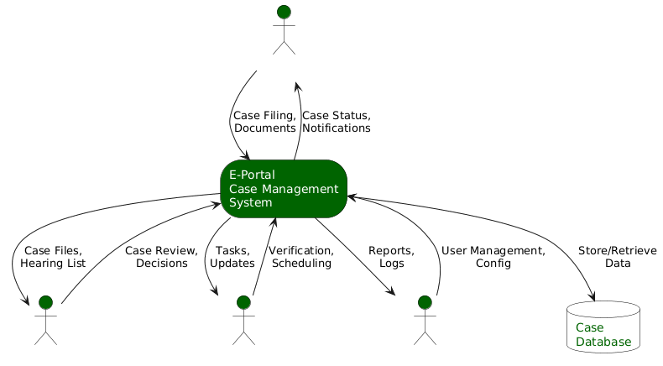
Figure 4.3. DFD Level 0
DFD Level 1
The DFD Level 1 illustrates the processes of the e, Portal in great detail. The system is broken down into main modules including User Authentication and Authorization, Case Management, Hearing Scheduling, Document Management, and Notification Management. The processes then interact with the appropriate data stores such as User Database, Case Database, Document Repository, and Notification Logs.
The user authentication process confirms a user's access rights before the user is allowed to carry out any more actions. Case management is responsible for case filing and case tracking. Hearing scheduling takes care of the distribution of hearing dates and communication with those involved. Document management is responsible for the uploading, storing, and retrieval of legal documents. Notification management creates notifications and SMS reminders from the system events. This level of the DFD explains the internal processing of data and the functionality of the system more clearly.
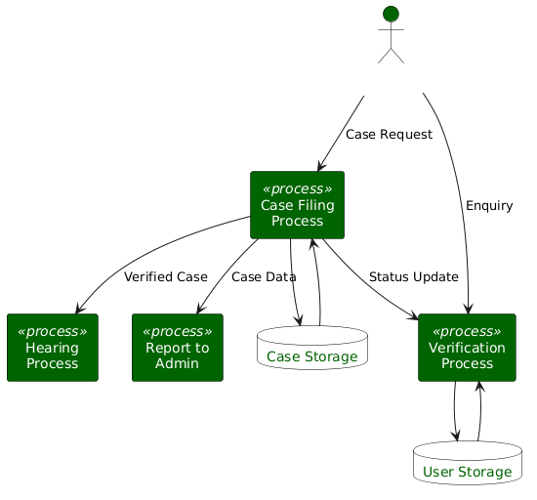
Figure 4.4. DFD Level 1
    - Use Case Diagrams
Use Case Diagrams show how different users interact with the E, Portal for Facilitating Case Management and Hearings. Such diagrams provide an insight into the functional domain of the system by delineating various user roles and their allowed activities. A use case denotes a particular feature that the system provides whereas actors identify the external agents that the system interacts with.
The major actors in the system are the Judges, Advocates, Litigants, Court Staff, and Administrators. Each actor has a set of functions and a level of access that is uniquely determined by the role. The use case diagram is a guarantee of transparency in role, based access and it also depicts the system's facilitation of judicial workflows in a neat manner.
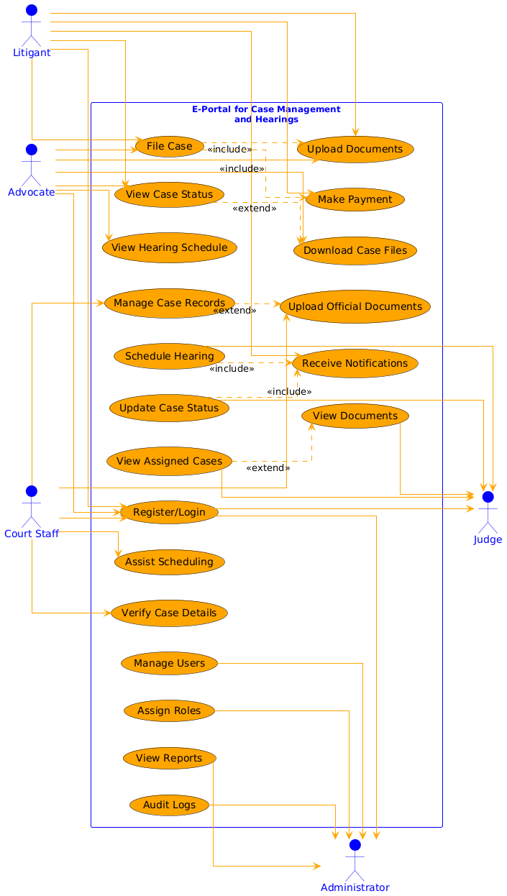
Figure 4.5. Use Case Diagram

  - Database Design
The database design for the E, Portal Case Management System is made to accommodate very complicated judicial-workflows with a lot of users, levels of courts, and secure case handling. It adopts a hybrid NoSQL style by combining embedded documents and referenced entities for a very good mix of performance, scalability, and data consistency.
Main elements like LegalCase, Advocate, Litigant, Clerk, and CourtAdmin define the framework of the system; they help in the functionalities of case filing, verification, assignment, and hearing management in district, specific jurisdiction areas.
The LegalCase component is the hub where all the litigants, advocates, hearings, documents, as well as the verification that are related to the case, are connected. There are other entities like CourtCalendar, Notice, EnrollmentRecord, OTPVerification, and BlacklistedToken which are used for scheduling, communication, advocate validation, secure authentication, and session control respectively. StateDistrict type entities are also present as reference giving a standardized validation for jurisdictional data.The whole idea is to keep the data accurate and allow access only to the authorized users, recording the actions and managing the entire judicial case process securely.
Table 4.4: Database Entities Description
Entity Name | Description
Advocate | Stores registered advocate details, bar enrollment information, verification status, practice jurisdiction, and representation requests for legal cases.
Litigant | Maintains information about plaintiffs and defendants, their personal details, login credentials, and associated advocates for filed cases.
LegalCase | Core entity representing judicial cases, including party details, advocates, hearings, documents, verification status, district, and AI-based matching metadata.
Clerk | Court staff responsible for case verification, preliminary management, and administrative coordination within a specific court and district.
CourtAdmin | Administrative authority managing case assignment, notices, court calendars, and AI-assisted case specialization matching.
CourtCalendar | Stores court working days, holidays, and timings used for automated hearing scheduling.
Notice | Contains official court notices and announcements published at the district or advocate-specific level.
EnrollmentRecord | Reference data used to verify advocate registration against Bar Council enrollment records.
OTPVerification | Temporary entity used for secure, time-bound OTP-based verification during case-related operations.
BlacklistedToken | Stores invalidated JWT tokens to enforce secure logout and session termination.
StateDistrict | Reference entity maintaining valid state and district mappings for jurisdiction validation across the system.

ER Diagram
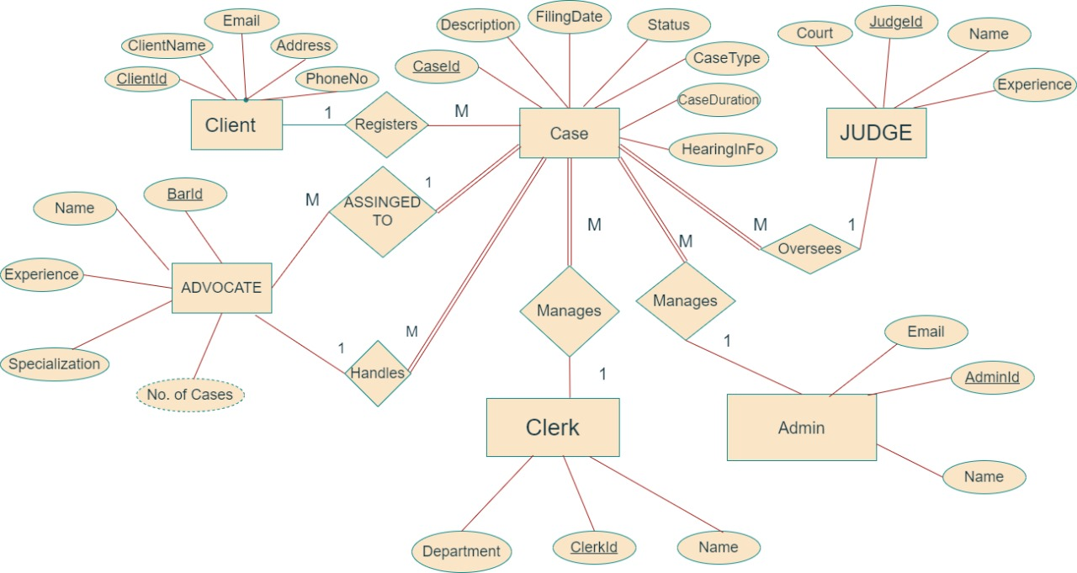
Figure 4.5. ER Diagram

CHAPTER 5
IMPLEMENTATION

  - Introduction Tools and Technologies Used
The selected tools and technologies are instrumental in ensuring secure handling of judicial information, delivering a smooth user experience, and enabling high system performance. The selection of the technology stack was made taking into account the project needs, availability of open source support, and the suitability of a judicial platform, which is role, based and multi, user, for the given technologies.
The system frontend is developed using React.js, which offers a lively and engaging user interface to different categories of stakeholders like judges, advocates, litigants, court staff, and administrators. React supports component, based development, which is great in terms of boosting code reusability and maintainability. Vanilla CSS is applied for styling, which makes it possible to present a neat and consistent interface on different devices.
Backend of the business logic, API handling, authentication, and workflow management is Node.js based with Express.js. Backend connection with the mongo-database are by lightweight RESTful APIs, and role-based access control is being implemented through JSON Web Tokens (JWT). Security measures are also improved further by SSL/TLS encryption and for data transmission in a very secure manner.
The database layer is managed using MongoDB, a NoSQL database that is highly suitable for storing unstructured and document based judicial data such as cases data , hearings data, documents, and user roles. MongoDB provides very high scalability and a flexible and strong schema design, which is very beneficial when dealing with judicial requirements that are tend to change.
Table 5.1: Tools and Technologies Used
Category | Tool / Technology | Purpose
Frontend | React.js | Building dynamic and role-based user interfaces
Styling | Vanilla CSS | Designing responsive and consistent UI
Backend | Node.js | Server-side logic and request handling
Framework | Express.js | API development and routing
Database | MongoDB | Storage of cases, users, hearings, and documents
Authentication | JWT (JSON Web Token) | Secure role-based authentication
Security | SSL / TLS | Secure data transmission
API Architecture | RESTful APIs | Communication between frontend and backend
Version Control | Git / GitHub | Source code management
Deployment Environment | Cloud / Local Server | Hosting and deployment of the application
Development Tools | VS Code, Postman | Coding and API testing

CHAPTER 6
TESTING AND MAINTENANCE

  - Testing Overview
Tests are conducted to confirm that the E, Portal for Facilitating Case Management and Hearings operates smoothly, safely, and effectively under real, life situations. Considering that the system manages confidential judicial data and facilitates various user roles, it is vital that thorough testing is carried out to not only check the features but also to measure the system's security, performance, and reliability.
The testing activities focus on the requirements set forth in the SRS document and the pilot, based evaluation methodology. All the major modules like authentication, case management, hearing scheduling, document handling, and notifications were subjected to tests separately and also in integration to verify overall accuracy.
  - Types of Testing Performed
The following testing techniques were used during system validation and check:
    - Functional Testing
Functional testing verifies that each feature of the system works fine and according to the specified requirements. Modules such as user-login, case filing, document-upload, hearing scheduling, and notifications were tested using valid and invalid inputs in a good testing environment.
    - Integration Testing
Integration testing is done to check whether the components such as frontend, backend, and database components work together properly. The correctness of the API JSON responses, data consistency or the inconsistency, and uninterrupted workflow were also being checked across the modules.
    - Security Testing
Security testing was performed to ensure that role, based access control, JWT authentication, OTP verification, and prevention of unauthorized access work correctly. Also, token invalidation and session handling were checked.
    - Performance Testing
Performance testing evaluates system responsiveness under concurrent access. Multiple user roles were simulated simultaneously to test response time, stability, and scheduling efficiency.
  - Test Case Design
Test cases were prepared concentrating on major workflow of the system and different types of users which are essential in the system. Every test case defines input conditions, expected results, and actual outcomes.
Table 6.1: Sample Test Cases
Test Case ID | Module | Test Description | Expected Result | Status
TC-01 | Authentication | Login with valid credentials | User logged in successfully | Pass
TC-02 | Authentication | Login with invalid password | Access denied | Pass
TC-03 | Case Management | File new case with valid data | Case ID generated | Pass
TC-04 | Case Management | Upload invalid document format | Upload rejected | Pass
TC-05 | Hearing Scheduling | Schedule hearing with available slot | Hearing scheduled | Pass
TC-06 | Security | Access admin feature as litigant | Access denied | Pass
TC-07 | Notification | Hearing scheduled notification | Notification delivered | Pass

  - Test Environment
The testing environment was designed to closely simulate real-world judicial usage.
Table 6.2: Test Environment Configuration
Component | Specification
Frontend | React.js (Chrome Browser)
Backend | Node.js with Express
Database | MongoDB
Authentication | JWT, OTP
Deployment | Local / Cloud-based server
Users Simulated | Judge, Advocate, Litigant, Clerk, Admin

  - Test Results and Observations
Test results show that the system is dependable in all main modules. Functional testing verified the accurate execution of case filing, verification, scheduling, and document handling processes.
Integration testing revealed efficient communication between frontend, backend, and database layers.
Security tests ensured that attempts of unauthorized access were effectively prevented, and all critical operations were recorded.
Performance tests indicated that the system behaved consistently under simultaneous users with good response times, thereby confirming the system's scalability and strength.
  - Maintenance Strategy
Maintenance helps to keep the system running smoothly and makes it easier to accommodate changes and new requirements after the deployment of the system. The system is architected in a very modular design, thereby the replacement or upgrading of any component without the need to change the whole system.
Examples of maintenance work are bug fixing, updating security patches, database tuning, and checking system performance. Having automated backup and audit trails also help to recover data and track the system activities in the event of system breakdowns.

Table 6.3: Maintenance Activities
Activity | Description
Bug Fixing | Resolving reported system issues
Security Updates | Updating authentication and encryption mechanisms
Database Backup | Regular automated backups
Performance Monitoring | Monitoring response time and load
Feature Enhancement | Adding new modules and improvements

  - Conclusion of Testing and Maintenance
This E, Portal has been confirmed through variouskind of tests to comply with all functional, performance, and security requirements written in the SRS document. The adopted maintenance strategy is tend towards the system's sustainability, scalability, and preparedness for actual use in the judiciary world and different types of the workflows.

CHAPTER 7
RESULTS AND DISCUSSIONS

  - Description of Modules with Snapshots
The E, Portal for Facilitating Case Management and Hearings is realized as a modular system where each module is dedicated to performing one function within the judicial workflow. The User Authentication Module provides safe login functionality through the use of role, based access for judges, advocates, litigants, clerks, and administrators. The Case Management Module provides capabilities to file, verify, assign and track cases anytime during the case lifecycle.
The Hearing Management Module schedules hearings automatically by matching the court calendars and the parties' availability, thus reducing conflicts and postponements. The Document Management Module allows a very secure uploading, storage, versioning, and retrieval of legal documents to allow traceability and confidentiality.
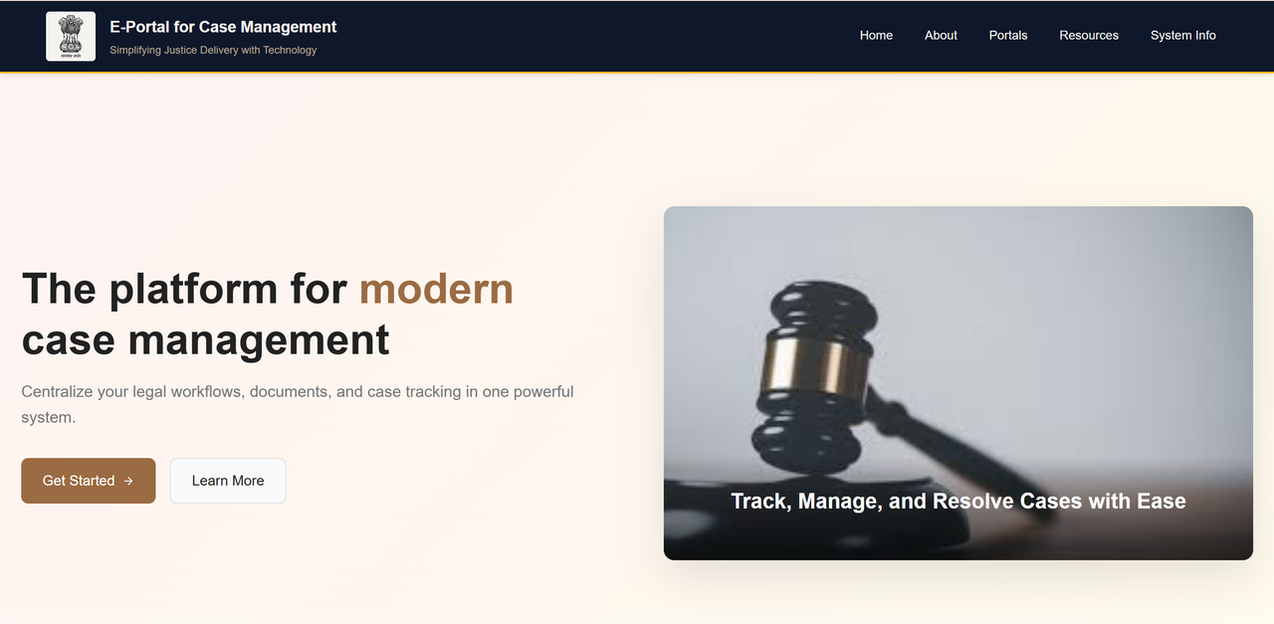

Figure 7.1. E-portal Dashboard

Figure 7.2. Admin Login page
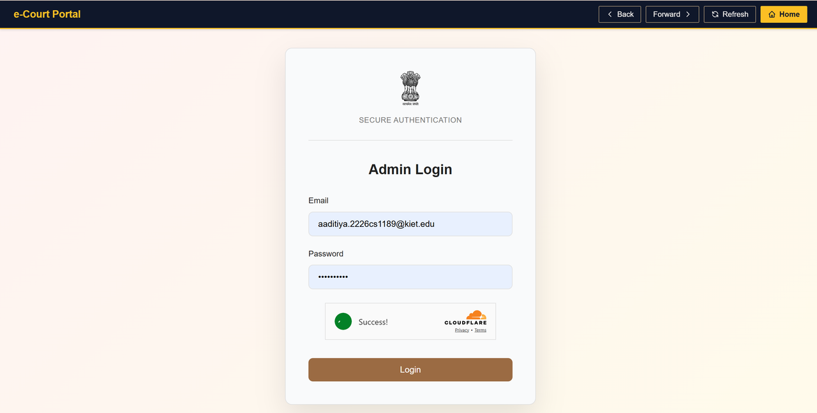
Figure 7.3. Admin Panel
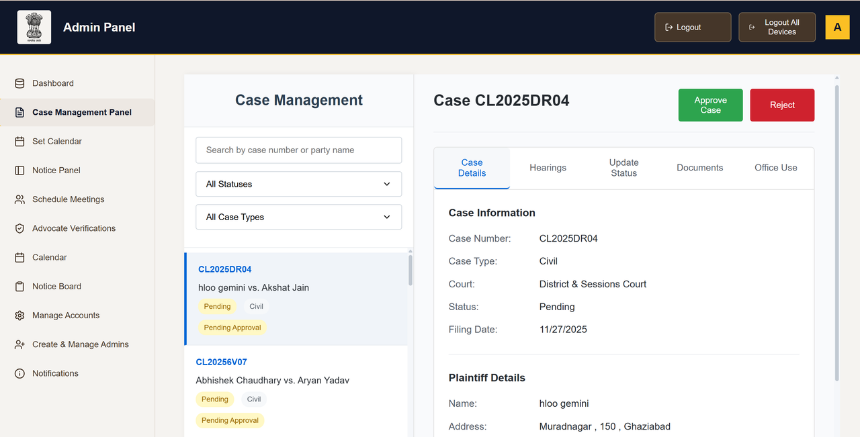

Figure 7.4. Litigant Dashboard
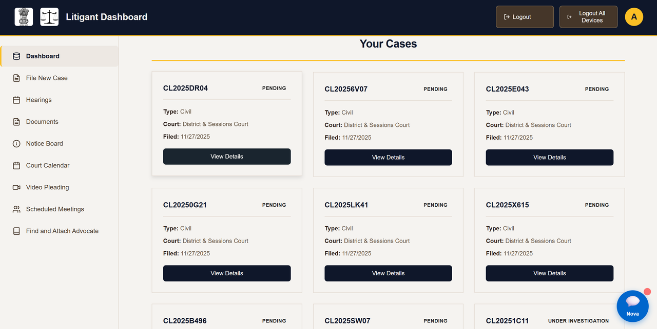
  - Key Findings of the Project
The implementation and testing of the system revealed several significant results. Automation of case filing and scheduling greatly reduced the amount of manual work and the time needed for processing. Role, based access control guaranteed that only authorized and legitimate users could interact with judicial data. The notification mechanism enhanced communication between stakeholders and thus, reduced the number of missed hearings or deadlines.
The system was able to perform well with multiple users accessing it concurrently and it was able to keep data consistency among various modules. Users were able to access court services more easily, they did not have to rely so much on making physical visits to the courts and they were able to see their cases more transparently through case tracking as a result of the feedback from the users.
Table 7.1: Key Findings Summary
Parameter | Observation
Case Filing Process | Faster and fully automated
Hearing Scheduling | Reduced conflicts and delays
Data Security | Strong role-based access control
User Accessibility | Improved through web-based access
System Stability | Stable under concurrent usage

  - Brief Description of Database with Snapshots
The system is built around a centralized MongoDB database that serves as a repository and a management tool for all the data relating to the judiciary. The main categories are Advocate, Litigant, LegalCase, Clerk, CourtAdmin, Document, Hearing, and Notification.The schema of the database is well geared to support embedded documents as well as references which in turn facilitate the efficient handling of the intricate relations that exist between cases, users, hearings, and documents.
Figures for the storage depict, among others, the organization of files concerning case records, connection of information of parties, storage of data about documents, and scheduling hearings. The database employs line, up fields, compartmentalized data access according to roles, and records of audit to guarantee the integrity and safety of the data as well as speedy retrieval. This database format is quite capable of bearing the load and provides for the immediate performance demanded by a judicial case management system.
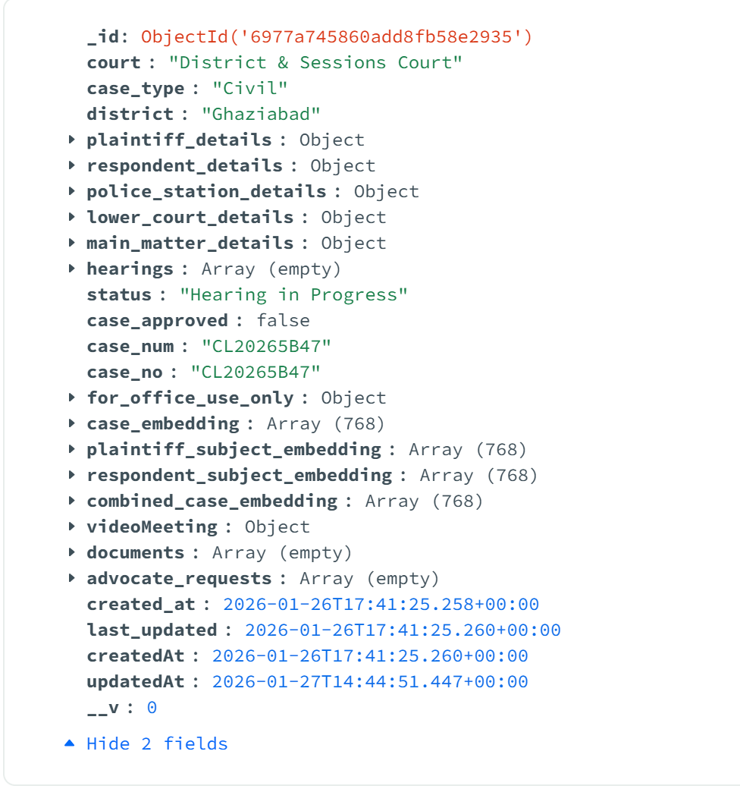
Figure 7.5. Database Case Document

CHAPTER 8
CONCLUSION AND FUTURE SCOPE

  - Conclusion
The E, Portal for Facilitating Case Management and Hearings has resolved a number of issues that are typical of the delivery of justice in a court chamber by the traditional systems i.e. manual working, non, transparency, and procedural delay. The system comprises a digitized judicial process of case filing, hearing scheduling, document management, and notifications that provide a centralized and secure platform for all judicial stakeholders.
The introduction of role, based access control guarantees data confidentiality and access restriction. At the same time, the use of automation helps to decrease the number of tasks performed by the administration and therefore also human errors. Results from performance and security tests show that the system is not only stable and scalable but also capable of handling a large number of users concurrently in an efficient manner.
The project has sufficiently fulfilled the objectives of making judicial operations more accessible, transparent, and efficient.
  - Future Scope
The E, Portal for Facilitating Case Management and Hearings is a great solution to the main problems of traditional court systems that involve manual procedures, lack of transparency, and delays in court hearings. Through digitalization of the key judicial processes such as case filing, hearing scheduling, document management, and notifications, the system offers a single and secure platform for all judicial stakeholders.
It is possible to integrate advanced AI, based case prioritization and decision, support systems to help judges and administrators together with workload management. The addition of fully integrated video conferencing facilities for virtual hearings can serve as an extension of the digital court system and even reduce the need of going to physical courts.
Among other benefits, the use of biometrics authenticating and blockchain, based audit trails can considerably upgrade cybersecurity measures, thus, ensuring data integrity and faithfulness are strengthened.

REFERENCES

- A. Baig, “The role of technology in enhancing access to justice: Challenges and opportunities in the 21st century,” AL-AASAR Journal: Quarterly Research Journal, vol. 2, no. 1, pp. 774–779, 2025.
- D. Pitaloka, “E-court: A digital disruption in law enforcement and its impact on judicial efficiency in Indonesia,” Ex Aequo Et Bono Journal of Law (EAEBJOL), vol. 2, no. 2, pp. 82–95, 2025. doi: 10.61511/eaebjol.v2i2.2025.1404.
- D. Putranti, U. T. Putri, A. Prahara, and M. S. Quddus, “Proposing digital copyright infringements enforcement through Internet Court in Indonesia: Fostering the existing E-Court system,” E3S Web of Conferences, vol. 622, p. 03006, 2025. doi: 10.1051/e3sconf/202562203006.
- F. A. A. C. Campos, J. C. B. Silva, F. B. Feitosa, I. O. Reis, E. C. Caritá, M. F. Moll, C. A. A. Ventura, and J. C. Sánchez, “Theoretical and bioethical foundations for the development of the psychosocial rehabilitation project application,” Saúde em Redes Journal, vol. 11, no. 1, pp. 1–18, Feb. 2025. doi: 10.18310/2446-4813.2025v11n1.4430.
- Y. D. Prasetyo, D. Muhtada, and Martitah, “The effectiveness of using e-court services in realizing electronic religious courts,” Eduvest – Journal of Universal Studies, vol. 5, no. 4, pp. 4415–4431, Apr. 2025.
- R. Nababan, B. Habeahan, H. Siregar, and F. M. Simanjuntak, “The existence of online trials (electronic court) in civil cases in Medan State Court, Indonesia,” Golden Ratio of Law and Social Policy Review, vol. 4, no. 2, pp. 83–97, 2025. doi: 10.52970/grlspr.v4i2.929.
- H. A. A. Jaber, “Improving security for the Libyan e-government portal: A multi-factor authentication model utilizing NID-SIM linkage,” Libyan Journal of Informatics, vol. 2, no. 1, pp. 43–53, Jun. 2025.
- CH. Prabhavati, A. Mounika, G. Devi Sri, K. Lahari, and K. V. Krishna, “Legal Connect: e-Portal for Facilitating Case Management Hearings of Various Types of Cases,” Int. J. Eng. Sci. Adv. Technol. (IJESAT), vol. 24, no. 5, pp. 322–327, May 2024.
- P. Saxena, “Technological innovations in India’s legal sector for access to justice during and post pandemic,” in 2023 Law and Development Conference, Singapore, Dec. 2023.
- A. Maralbaeva, E-justice and Cyber Security: Balancing between Openness of the Courts and Data Protection in Kyrgyzstan. United Nations Development Programme (UNDP), 2022. [Online]. Available: Link.
- R. K. Ahmed, O. Ahmed, I. Pappel, A. Reitsakas, and D. Draheim, “The role of digital transformation in fostering transparency: An e-Court system case study,” in Lecture Notes in Computer Science. Cham, Switzerland: Springer Nature, Sep. 2022, doi: 10.1007/978-3-031-15342-6_17.
- C.-L. Lee, “E-justice in Taiwan: The derivative inquiries from constitutional perspectives in the digital age,” Ritsumeikan Law Rev., no. 40, pp. 55–67, 2022.
- B. G. S. Grepon, “Designing and implementing e-justice systems: An information systems approach to regional trial court case docket management in Northern Mindanao, Philippines,” Int. J. Multidiscip. Acad. Res., vol. 8, no. 1, 2020.

